Attention in Aversive Choice

Introduction

Figure 1. aDDM Examples. (Gain Predictions) With positive value signals and an attentional parameter $θ∈[0,1]$, the accumulator is biased towards the fixated option. (Loss Predictions) With negative value signals, the accumulator is instead biased towards the non-fixated option. Colored vertical bands illustrate fixation locations.

- The standard aDDM predicts that attention in aversive choices should bias decisions away from more attended options.
- This would reflect as reverse net fixation bias and reverse last fixation bias in choices. See Row 1 of Supplementary Figure 1 for simulations of this phenomenon.

Results

Paradigm

Figure 2. Studies. Trials begin with a forced fixation cross for 1 s. In Study 1, the fixation cross is fixed in the center; but in Study 2, it varies evenly between the left, center, and right side of the screen. Participants then make a binary choice between two lotteries on the left and right side of the screen. In the gain condition, the lotteries have weakly positive outcomes. In the loss condition, they have weakly negative outcomes. As they make their choice, participants have free response times while we record the location of their gaze. After participants make a choice, feedback about the selected option is presented for 1 s. In Study 1, lotteries are presented as 100 dots in a grey circle. Green, white, and red dots represent the probability of gaining $10, $0, and -$10, respectively. The number of green or red dots is drawn uniformly from $p∈\{45,…,55\}$, and the number of white dots is $100-p$. In Study 2, the probabilities and outcomes for each lottery are presented in numerical format with an implicit 0 outcome. Differences in expected value are bounded between [-$4, $4], depending on condition.

- To test this hypothesis, we run two eye-tracking studies to investigate the role of attention in aversive choice.
- In Study 1, optimal information sampling could involve comparing colored and white dots, or it could involve simply counting green dots in the gain condition and white dots in the loss condition. Then inputs to the sequential sampling model are always positive. We run Study 2 to avoid ambiguity in the value signals.

Basic Psychometrics

Figure 3. Basic Psychometrics. The top row depicts the probability of choosing the left item as a function of the normalized expected value difference between the left and right lotteries (``relative value''). Differences in expected values were normalized by dividing by the maximum magnitude of the difference. The middle row depicts response time as a function of normalized choice difficulty, measured by the expected value difference between the best and worst lottery then divided by the maximum magnitude of the difference. The bottom row depicts the number of fixations as a function of normalized choice difficulty. Columns indicate which data set generated the figures. Error bars show the standard error of the mean across participants.

- In both studies, there were no meaningful differences in average choices or number of fixations across the two conditions.
- Response times were slightly slower in the loss condition in Study 2. We believe this is partially driven by self-reported difficulty in comprehending loss lotteries with implicit zero outcomes.
- See Supplementary Figure 2 for impact of attentional manipulations in Study 2 on basic psychometrics. Slight changes to average choices in gain condition, pretty much no impact on average choices in loss condition, or on response times.
- See Supplementary Table 1 for regressions associated with the figures.

Fixation Process

Figure 4. Fixation Process. The first row depicts the probability of first fixating on the best lottery as a function of normalized choice difficulty. The best lottery is determined by expected value, ignoring risk preferences. The second row depicts fixation durations as a function of fixation type. The third row depicts middle fixation durations as a function of normalized choice difficulty. The fourth row depicts first fixation durations as a function of normalized expected value of the first seen lottery. The fifth row depicts net fixation duration to the left lottery as a function of its normalized relative expected value. Columns indicate which data set generated the figures. Error bars show the standard error of the mean across participants.

- No significant differences across conditions in first fixation to best, middle fixation durations, or first fixation durations.
- In Row 2, fixations durations were significantly longer in loss condition, but differences are small.
- In Row 5, we see participants spend increasingly more time looking at the option they favor more. In Study 2, we see the right-side lottery receives more attention on average. See Supplementary Figure 3 for an explanation: participants most frequently utilize 2 fixations when the fixation cross starts left, whereas they most frequently utilize 3 fixations when the fixation cross starts right. This is not explained by Bayesian models of attention allocation.
- See Supplementary Figure 4 for impact of attentional manipulations on Fixation Process in Study 2. Slightly longer first fixation durations when fixation cross left or right compared to center. Net fixation durations favor left more, the closer the fixation cross gets to the left side.
- See Supplementary Table 2 for regressions associated with the figure, and Supplementary Table 3 for regressions associated with Supplementary Figure 3.

Attentional Choice Biases

Figure 5. Attentional Choice Biases. The top row depicts the corrected probability of choosing the left lottery as a function of the net fixation to the left lottery. The corrected probability is computed by subtracting from each choice observation (1=left, 0=right) the proportion of which left is chosen at each relative value. The bottom row depicts the probability of choosing the last fixated lottery as a function of the normalized relative expected value of the last fixated lottery. Columns indicate which data set generated the figures. Error bars show the standard error of the mean across participants.

- Unlike the predictions of the aDDM, attentional choice biases did not experience a reversal in the loss condition. In fact, for both studies, they are nearly identical in both conditions.
- Row 3: no evidence of first fixation location bias.
- See Supplementary Figure 5 for effect of attentional manipulations on attentional choice biases. Not much impact on net or last fixation bias. It does impose a small first fixation location bias.
- See Supplementary Table 4 for regressions associated with the figure.

Model Selection

- Supplementary Figure 1 uses simulations to show how different choice processes would affect the behavioral predictions of the aDDM.
  - Row 1 shows that the standard aDDM with $θ∈(0,1)$ cannot explain the lack of attentional choice bias reversals in losses.
  - Row 2 shows that the aDDM with $θ∈\left(0,2\right)$ can predict the behavior in our data. However, $θ>1$ does not make intuitive sense.
  - If people accumulate evidence over raw value signals but select the opposite choice from the boundary that was hit (OPPaDDM), then we can capture net fixation bias, but we lose the ability to capture choice accuracy and last fixation bias. See Row 3.
  - In the loss condition, if people first search for the worse choice using transformed value signals and then choose the opposite option (TrOPPaDDM), then we can capture choice accuracy and response times, but we cannot mimic the lack of attentional choice bias reversals in the loss condition. See Row 4.
  - There are two attentional models that have been previously proposed that can explain our data: the AddDDM and the RaDDM. The AddDDM postulates that attention plays a value-independent role in the sequential sampling process. The RaDDM incorporates reference-dependent value signals into the aDDM, with a reference point rule that fixes the reference point to the minimum possible value in a context. It could also be a form of range normalization, except range normalization and our reference-point rule are indistinguishable with various levels of drift rate.
  - The AddDDM and RaDDM are both capable of capturing choices and response times, while maintaining identical choice biases in both gains and losses.
Figure 6. Model Comparison. Each plot depicts the posterior model probabilities within a study and condition. Each dot represents the posterior model probability of a model (x-axis) for a single participant. For each participant, there are two dots that sum to 1 per plot: one for the AddDDM and one for the RaDDM. Boxplots present the 25th, 50th, and 75th percentiles. AddDDM: the additive model of attention. RaDDM: the reference-dependent aDDM with standard $\left[0,1\right]$ bounds on the attentional parameter. Data from the training subset of joint dataset.

- We fit the AddDDM and RaDDM to data from our studies using the aDDM Toolbox in Julia, developed by Enkavi et al. (2024).
- To decide which model is providing the best description of the choice process in losses, we first compare posterior model probabilities of the AddDDM and RaDDM. Similar to Smith & Krajbich (2019), the AddDDM and RaDDM both perform well in our data. Therefore, we rely on additional tests for model comparison.
- Supplementary Figure 6 shows that posterior model probabilities are capable of matching the correct model to data simulated using either the AddDDM or the RaDDM (i.e. model recovery is successful).
- Supplementary Figure 7 shows the same posterior model probabilities, separately for the exploratory and confirmatory datasets. Results are consistent with the joint dataset.
- Supplementary Figure 8 shows Alluvial plots depicting how frequently participants had matching best-fitting models in the gain and loss conditions.

Table 1. Model Comparison Regression Tests in the Loss Condition

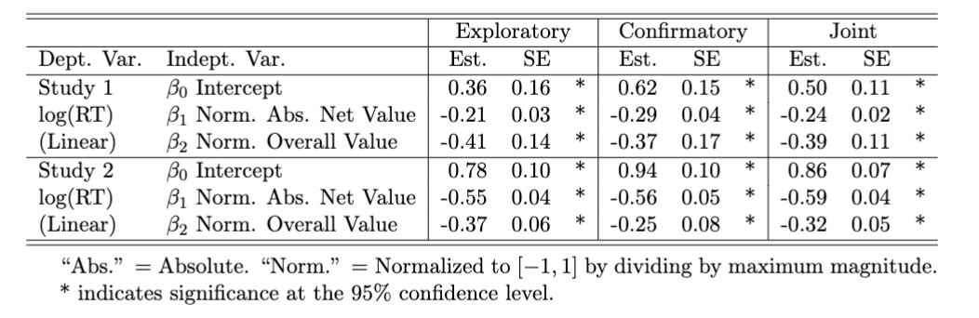

- The relationship between response times and overall value, emphasized in Smith and Krajbich (2019), provides a test for what model our participants might be using.
- Supplementary Table 5 shows that the RT(OV) test is capable of distinguishing between data simulated using the aDDM, AddDDM, and RaDDM in the loss condition. RTs are increasing in overall value with the aDDM, independent with the AddDDM, and decreasing with the RaDDM.
- Table 1 shows the results of the RT(OV) test applied to data from both of our studies. The tests reveal a significantly negative relationship between RT and OV in the loss condition for both studies. This is only predicted by the RaDDM and suggests that people are using some form of reference-dependent value signals during evidence accumulation.
- Due to the results of our model comparison regression test, we focus on the results of the RaDDM in this paper.
- Supplementary Table 6 attempts to replicate the RT(OV) results from Smith and Krajbich (2019) in the gain condition. We find that RT(OV) is significantly decreasing in the Study 1 Gain condition, but is insignificant in the Study 2 Gain condition.
- In datasets 5 and 6 of Smith and Krajbich (2019), probabilistic values ranged from 0 to 1, meaning overall values ranged from 0 to 2. In our datasets, normalized overall value ranged from -1 to 0. This means that our estimates for $β_{2}$ should be roughly 2 times larger than those found for datasets 5 and 6 in Smith and Krajbich (2019, “SK”). SK dataset 5 $β_{2}=-0.202$ and SK dataset 6 $β_{2}=-0.178$. Our estimates for $β_{2}$ are roughly twice as large as these, suggesting that the magnitude of the effect of overall value on response times is roughly the same in our study as in SK datasets 5 and 6.
- Repeating this exercise with SK datasets 1 through 3 (which used food stimuli, not probabilistic values), we find that our estimates of the effect of overall value on response times are slightly larger than those found by SK. SK datasets 1 through 3 had overall values ranging from 1 to 20. This means that our estimates for $β_{2}$ should be roughly 20 times larger. $β_{2}$ for those three datasets were -0.013, -0.009, and -0.010. Multiplying these by 20 yields -0.26, -0.18, and -0.20.

Reference-Dependent aDDM (RaDDM)

Figure 7. Participant-Level RaDDM Estimates. Estimates of the drift rate ($d$), noise ($σ$), and attentional bias ($θ$) in the loss condition as a function of their counterpart in the gain condition. Grey lines mark equality across the two conditions. Data from the joint dataset.
- Drift rates and noise are roughly similar across the gain and loss conditions in both Study 1 and 2.
- Magnitude of the drift rate is different between Study 1 and 2 due to different distributions of reference-dependent value signals in the two studies (i.e. different scaling for different distributions of evidence).
- In both studies, the attentional bias parameter is similar across conditions. In Study 2, it seems slightly larger in the loss condition than in the gain condition, which could explain the slightly different slope in last fixation bias in losses compared to gains.
- Supplementary Figure 9 shows these results are consistent across the exploratory and confirmatory datasets.
- Our RaDDM estimates are consistent with the basic psychometrics and attentional choice biases we observed in the data.
- To verify the model, we simulate behavior out-of-sample in Supplementary Figure 10. Out-of-sample trials were divisible by 10. The RaDDM qualitatively matches choices and attentional choice biases. Note that it overestimates response times when value differences are small. This is typically fixed by introducing collapsing boundaries to the aDDM, but the current version of the toolbox does not recover collapsing boundaries.
- Supplementary Figure 11 plots the individual estimates for the AddDDM, separately for the Exploratory, Confirmatory, and Joint datasets. Drift rates and noise are similar to the RaDDM. Additive attentional biases are also consistent with our data.
- Supplementary Figure 12 compares participants’ attentional bias estimates from the RaDDM and the AddDDM. Note that participants with larger attentional biases in the RaDDM also have larger attentional biases in the AddDDM.
- Supplementary Figure 13 plots out-of-sample predictions of the fitted AddDDM. Similar to the RaDDM, the model captures choices and attentional choice biases, but overestimates response times when value differences are small.

Supplementary Figures

Supplementary Figure 1. Simulations of Attentional Choice Biases. For each model and condition, we generated a simulated dataset of 200 trials for each of 25 simulated subjects, each with their own random draw of parameter values. Columns depict basic psychometrics (like Figure 3) and attentional choice biases (like Figure 5): (Column 1) Probability of choosing left lottery as a function of the normalized net expected value of the left lottery. (Column 2) Response times as a function of normalized net expected value of the left lottery. (Column 3) Corrected probability of choosing the left lottery as a function of net fixation to the left lottery. See Figure 5 for a description of the correction. (Column 4) Probability of choosing the last fixated option as a function of normalized net value of the last fixated option. (Row 1) Data simulated using the aDDM with $θ∈\left(0,1\right)$ in both conditions. (Row 3) Data simulated using aDDM with final choice = opposite of barrier hit. (Row 4) Data simulated using standard aDDM in gains, but in losses, value signals are multiplied by -1 and final choice = opposite of barrier hit. (Row 5) Data simulated using AddDDM with $η∈\left[0.001, 0.010\right]$. (Row 6) Data simulated using RaDDM with $θ∈(0,1)$. Error bars denote the standard error of the mean across simulated subjects.
Supplementary Figure 2. Basic Psychometrics with Attentional Manipulations. The top row depicts the probability of choosing the left lottery as a function of the normalized expected value difference between the left and right lottery. Value differences are normalized by the maximum possible value difference. The bottom row depicts response times as a function of the normalized choice difficulty. Choice difficulty is measured by the difference between the best and worst expected value and is normalized by the maximum possible choice difficulty. Columns denote the location of the fixation cross which manipulates the location of first fixation. Error bars denote standard error of the mean across participants. Data from the joint dataset.

Supplementary Figure 3. Additional Fixation Properties. The first row depicts the probability of first fixating left as a function of choice difficulty. The second row pools over all subjects in Study 2 and depicts histograms of the number of fixations in a trial, separately by condition and the location of first fixation. The third row depicts the second fixation duration as a function of the normalized relative value. The fourth row depicts the third fixation duration as a function of the normalized relative value.

Supplementary Figure 4. Fixation Process with Attentional Manipulations. The first row depicts the probability of first fixating on the best lottery as a function of normalized choice difficulty. The second row depicts the first fixation durations as a function of normalized expected value of the first seen lottery. The third row depicts average middle fixation durations as a function of normalized choice difficulty. The fourth row depicts the net fixation duration to the left lottery as a function of the normalized expected value difference. Columns denote the location of the fixation cross which manipulates the location of first fixation. Error bars denote standard error of the mean across participants. Data from the joint dataset.

Supplementary Figure 5. Attentional Choice Biases with Attentional Manipulations. The top row depicts the corrected probability of choosing the left lottery as a function of the net fixation time to the left lottery. Corrected probabilities are calculated by taking the choice observation (1=left, 0=right) and subtracting the proportion of times left was chosen at each value difference. The bottom row depicts the probability of choosing the last fixated option as a function of the normalized relative expected value of the last fixated lottery. Columns denote the location of the fixation cross which manipulates the location of first fixation. Error bars denote standard error of the mean across participants. Data from joint dataset.
Supplementary Figure 6. Model Recovery Exercises. For each column, we use one of the models to simulate multiple datasets with different parameter combinations. We then simultaneously fit the simulated data with both models and compare posterior model probabilities. (Left) We simulate 27 datasets for each combination of AddDDM parameters: $d∈\left\{.002, .005, .008\right\}, σ∈\left\{.02, .05, .08\right\}, η∈\left\{.001, .005, .009\right\}$. (Right) We simulate 27 datasets for each combination of RaDDM parameters: $d∈\left\{.002, .005, .008\right\}, σ∈\left\{.02, .05, .08\right\}, θ∈\left\{.1, .5, .9\right\}$. Rows are separated based on condition. Boxplots depict the 25th, 50th, and 75th percentiles.
Supplementary Figure 7. Posterior Model Probability as a Function of Model, Separated by Dataset, Study, and Condition. Each plot depicts the posterior model probabilities within a study and condition. Each dot represents the posterior model probability of a model (x-axis) for a single participant. For each participant, there are two dots that sum to 1 per plot: one for the AddDDM and one for the RaDDM. Boxplots present the 25th, 50th, and 75th percentiles. AddDDM: the additive model of attention. RaDDM: the reference-dependent aDDM with standard $\left[0,1\right]$ bounds on the attentional parameter.
Supplementary Figure 8. Best-Fitting Model for Each Participant Across Conditions. On the left, we plot the best fitting model for each participant in the gain condition. On the right, we plot the best fitting model for each participant in the loss condition. Colored lines connect the boxes from left to right, indicating for each participant whether the best fitting model in the gain condition is the same, or different, in the loss condition. Rows denote which study the participants belong to. Data from joint dataset.

Supplementary Figure 9. Participant-Level RaDDM Estimates, Split by Dataset. Estimates of the drift rate ($d$), noise ($σ$), and attentional bias ($θ$) in the loss condition as a function of their counterpart in the gain condition. Grey lines mark equality across the two conditions.

Supplementary Figure 10. RaDDM Out-of-Sample Predictions. (Top Left) The probability of choosing left as a function of the normalized relative expected value of the left option, as in Row 1 of Fig. 3. (Top Right) Response time as a function of the normalized best minus worst expected value, as in Row 2 of Fig. 3. (Bottom Left) Corrected probability of choosing the left option as a function of the net fixation time to the left option, as in Row 1 of Fig. 5. The corrected probability is computed by subtracting from each choice observation (coded as 1 if left chosen, and 0 otherwise) the proportion with which left is chosen at each relative expected value. (Bottom Right) The probability of choosing the last fixated option as a function of the normalized net expected value of the left option, as in Row 2 of Fig. 5. Rows separate the data by condition, and columns separate by study. Out-of-sample data consists of all trials divisible by 10 from all participants in joint dataset. 10 simulated datasets per participant. Error bars represent the standard error of the mean across all simulations for all participants.
Supplementary Figure 11. Participant-Level AddDDM Estimates, Split by Dataset. Estimates of the drift rate ($d$), noise ($σ$), and additive attentional bias ($η$) in the loss condition as a function of their counterpart in the gain condition. Grey lines mark equality across the two conditions.

Supplementary Figure 12. Comparing Attentional Biases Across Models. Plots depict fitted $θ$ from the RaDDM as a function of the fitted $η$ from the AddDDM, separately by study (columns) and condition (rows). Note that smaller $θ$’s and larger $η$’s correspond to more attentional bias. Blue lines indicate OLS regression line, with grey 95% confidence intervals. $η$’s are slightly jittered for visual clarity.

Supplementary Figure 13. AddDDM Out-of-Sample Predictions. (Top Left) The probability of choosing left as a function of the normalized relative expected value of the left option, as in Row 1 of Fig. 3. (Top Right) Response time as a function of the normalized best minus worst expected value, as in Row 2 of Fig. 3. (Bottom Left) Corrected probability of choosing the left option as a function of the net fixation time to the left option, as in Row 1 of Fig. 5. The corrected probability is computed by subtracting from each choice observation (coded as 1 if left chosen, and 0 otherwise) the proportion with which left is chosen at each relative expected value. (Bottom Right) The probability of choosing the last fixated option as a function of the normalized net expected value of the left option, as in Row 2 of Fig. 5. Rows separate the data by condition, and columns separate by study. Out-of-sample data consists of all trials divisible by 10 from all participants in joint dataset. 10 simulated datasets per participant. Error bars represent the standard error of the mean across all simulations for all participants.

Supplementary Tables

Supplementary Table 1. Regressions Associated with the Basic Psychometrics Results in Figure 3.
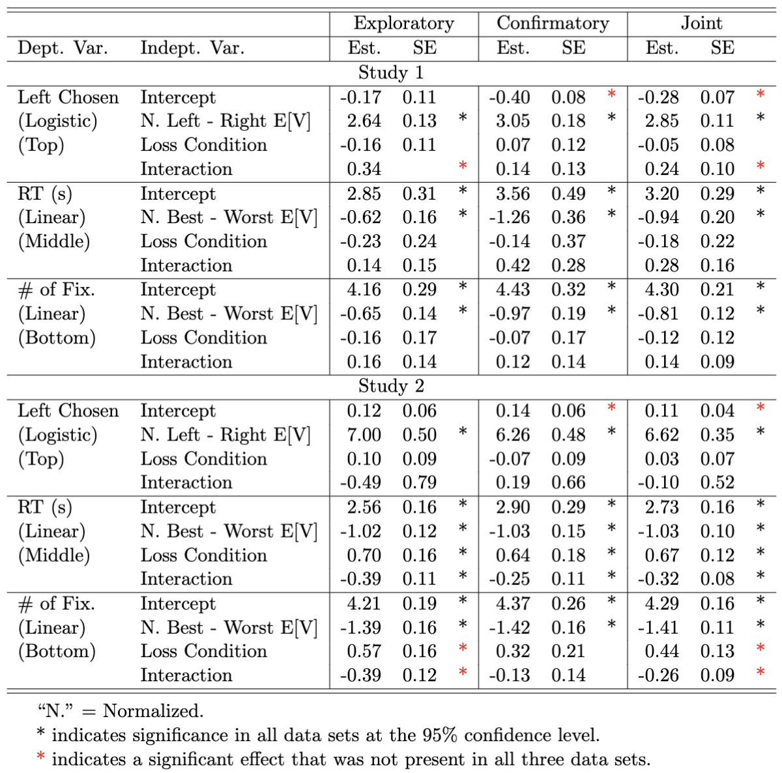
Supplementary Table 2. Regressions Associated with the Fixation Process Results in Figure 4.
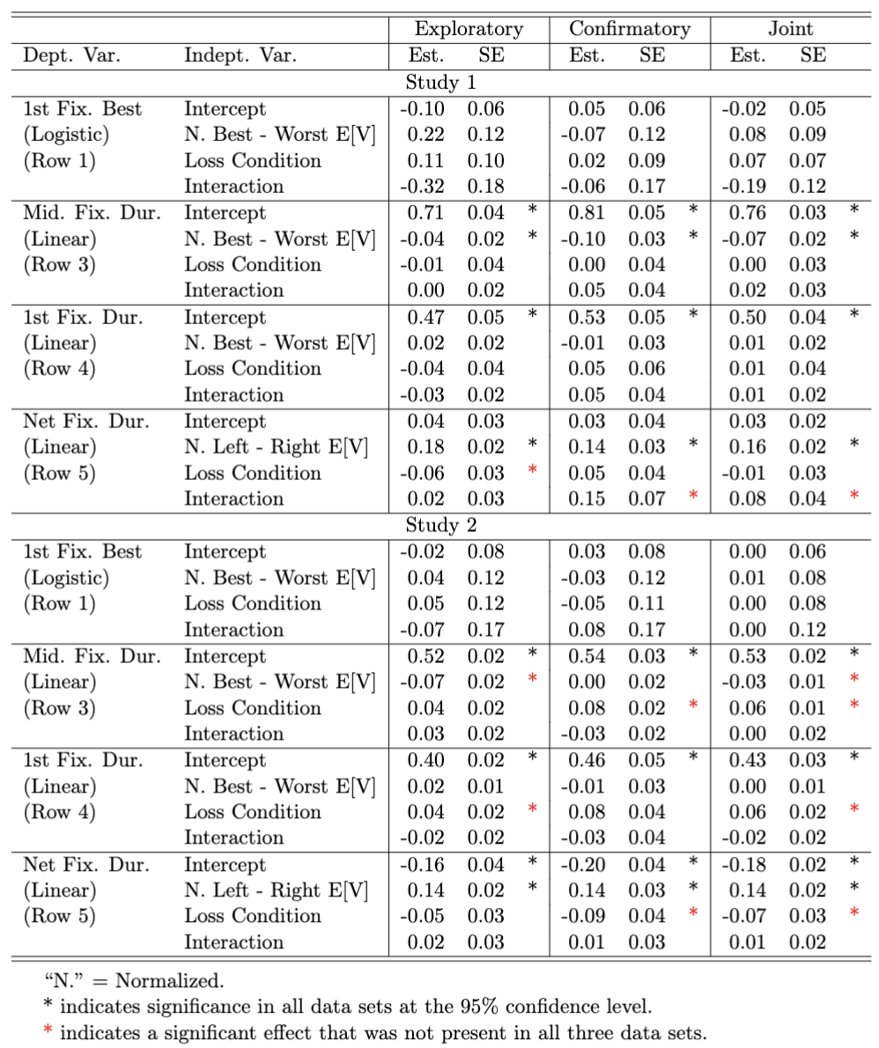
Supplementary Table 3. Regressions Associated with the Additional Fixation Properties in Supplementary Figure 3.
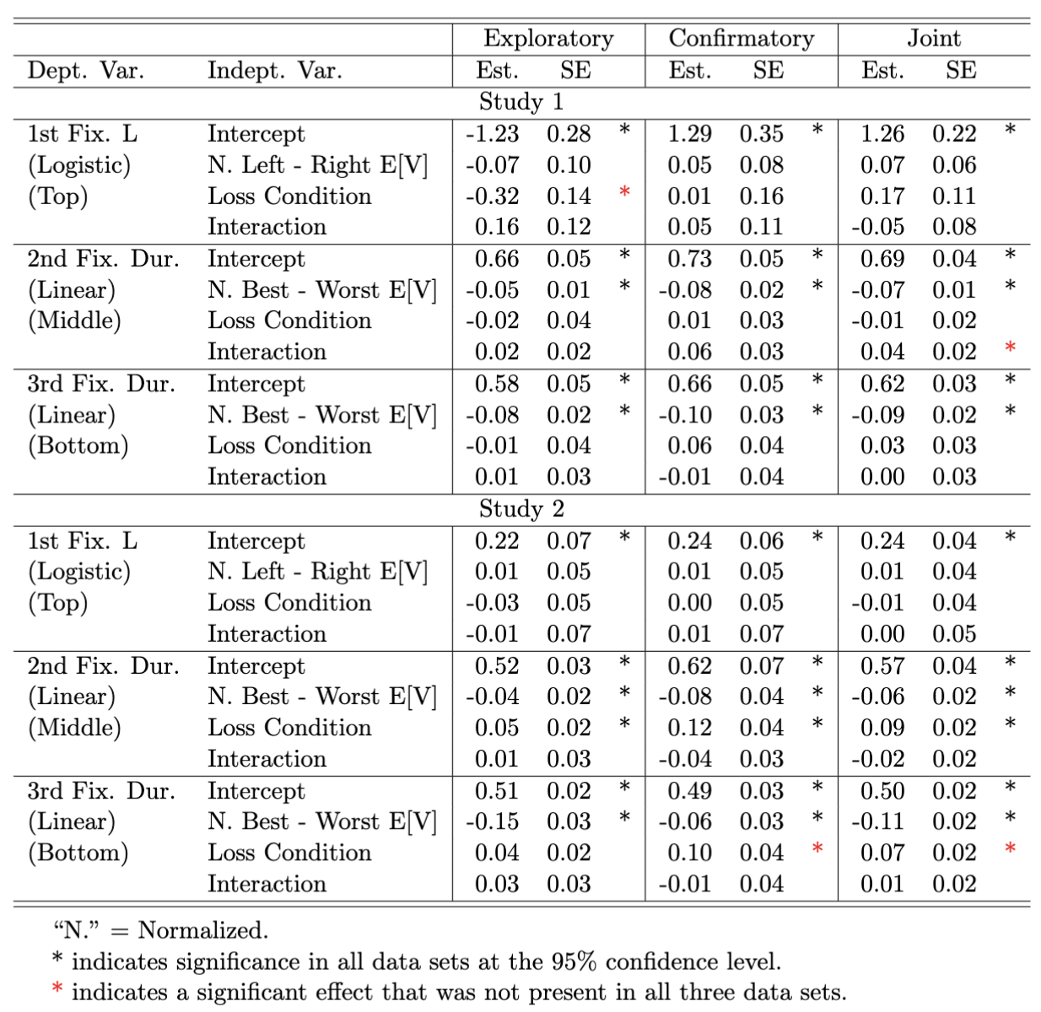
Supplementary Table 4. Regressions Associated with the Attentional Choice Bias Results in Figure 5.
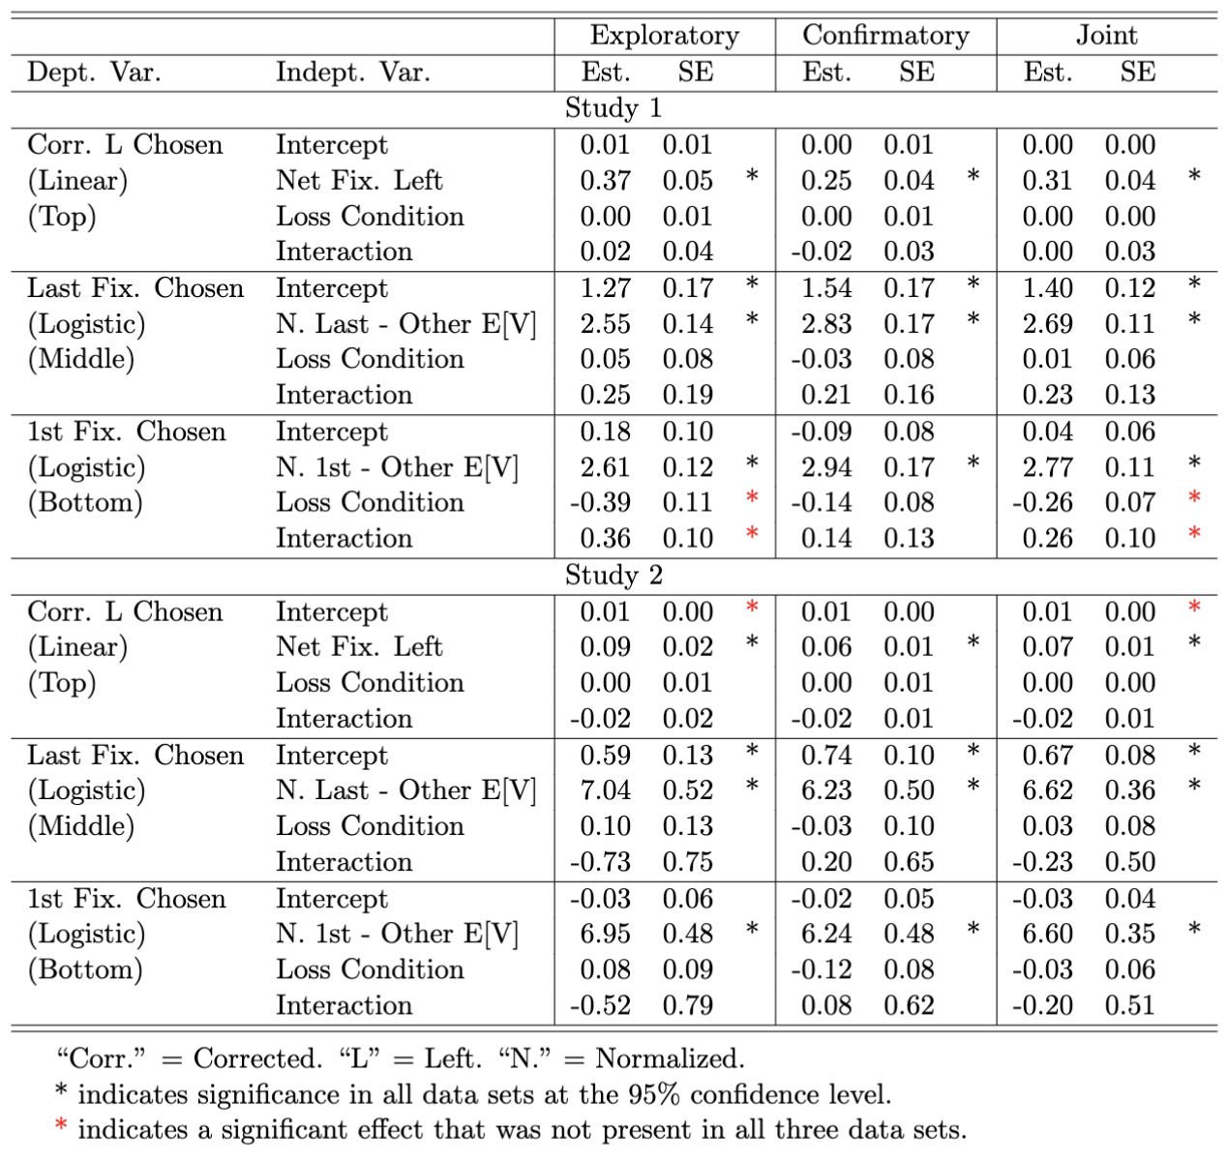
Supplementary Table 5. Model Comparison Regression Test in Simulated Loss Data Using aDDM, AddDDM, and RaDDM.
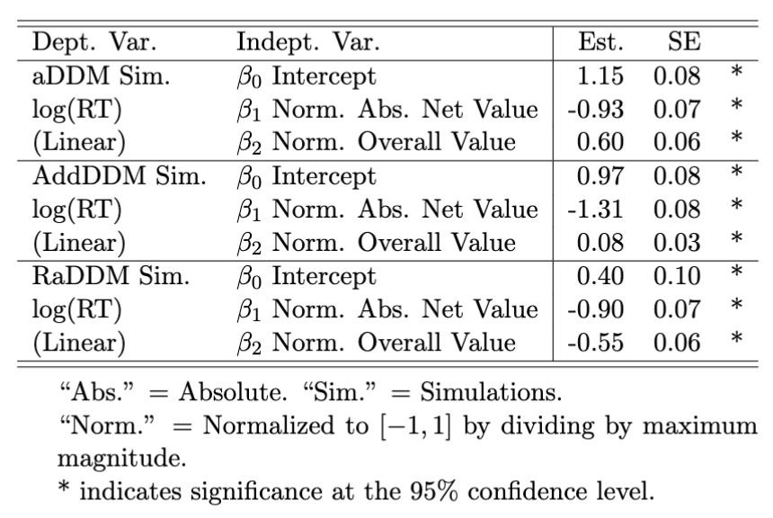
Supplementary Table 6. Replicating Smith & Krajbich (2019): RT is decreasing in overall value in gain condition.

